**Project Prospectus**

Title: *<Delete this text in light grey throughout>*

Notice: Dr. Bryan Runck

Author: Lauren Roach

Date: September 27, 2022

**Project Repository:** *<if applicable weblink to public repository>*

**Google Drive Link:** *<if applicable with data, notebooks, etc.>*

**Time Spent:** *<report to the nearest quarter hour>*

**Abstract**

This project will explore the capacity of an area within the state of Minnesota to provide access to resources needed for maternal wellbeing. By sourcing point data from Google Places, a map will be created that depicts the locations of various resources (listed in Table 1). Using a raster Ultimately, the project will culminate in a Maternal Wellbeing Index. I expect the urban areas to have a high score (high access to resources) and rural areas, particularly those in northern and western Minnesota, to have a low score (low access to resources).

Weighted linear

**Problem Statement**

The prenatal and post-partum periods are very significant moments for maternal health. Access to resources can shape the trajectory of a pregnancy and specifically affect the health of both the mother and baby. For this reason, understanding access or lack thereof to resources like dental care, groceries, and fitness opportunities for prenatal and post-partum women is crucial for public health practitioners.

*Describe the specific problem and the context. Provide an illustrative figure and/or context map here. In the table, translate the qualitative problem statement elements into specific requirements for the analysis.*

*Table 1. <insert caption>*

|  |  |  |  |  |  |  |
| --- | --- | --- | --- | --- | --- | --- |
| **#** | **Requirement** | **Defined As** | **(Spatial) Data** | **Attribute Data** | **Dataset** | **Preparation** |
| 1 | Road network | Raw input dataset from MNDOT | Road geometry |  | [Mn GeoSpatial Commons](https://gisdata.mn.gov/dataset/trans-roads-mndot-tis) |  |
| 2 | High volume traffic | > 100 cars per hour |  | Volume | AADT Data |  |
| 3 |  |  |  |  |  |  |
| 4 |  |  |  |  |  |  |

**Input Data**

*Describe the data in two paragraphs max. Fill out the table.*

*Table 2. <insert caption>*

|  |  |  |  |  |
| --- | --- | --- | --- | --- |
| **#** | **Title** | **Purpose in Analysis** | **Link to Source** | **Group** |
| 1 | Dentist offices | Raw input data for point location | Google Places | Group 1 |
| 2 | Mental health providers | Raw input data for point location | Google Places | Group 1 |
| 3 | Grocery stores | Raw input data for point location | Google Places | Group 2 |
| 4 | WIC locations | Raw input data for point location | Google Places | Group 2 |
| 5 | OBGYN Offices | Raw input data for point location | Google Places | Group 1 |
| 6 | Playgrounds | Raw input data for feature | Google Places | Group 3 |
| 7 | Fitness centers | Raw input data for point location | Google Places | Group 4 |
| 8 | Farmers markets | Raw input data for point location | Google Places | Group 2 |
| 9 | Pelvic Occupational Therapist/ Physical Therapist | Raw input data for point location | Google Places | Group 5 |
| 10 | Libraries | Raw input data for point location | Google Places | Group 3 |

**Methods**

*Include a data flow diagram or screenshot from model builder. Do references in line (Rammankutty, 2033). Document any and all steps that you did to the input data in the data flow diagram. Provide natural language description of the most important steps, giving a narrative arc and provide well formatting screenshots with a boarder and centered throughout.*

*Resources on Data Flow Diagrams:*

* [*https://www.visual-paradigm.com/tutorials/data-flow-diagram-dfd.jsp*](https://www.visual-paradigm.com/tutorials/data-flow-diagram-dfd.jsp)
* [*https://www.lucidchart.com/pages/data-flow-diagram/how-to-make-a-dfd*](https://www.lucidchart.com/pages/data-flow-diagram/how-to-make-a-dfd)

*Figure 1. Data flow diagram.*

*If appropriate, add in pseudo-code describing model algorithms and/or objects. If using mathematical equations, create a clear mapping between the reference equation, pseudo-code, and actual implementation in a programming language.*

* Find locations of points through Google Places and add data to map
* Generate tessalation: 10miles
* Select by location: Tessellation within MN
* Count the number of points in each grid using summarize within (add point count to each polygon) for each group; creating a new field which stores the count in each cell
* Medical and dental offices group (Group 1) is weighted more (50%) than other resources and this weighting calculation would be calculated in a new field
* Use weighted sum to find sum of scores of each cell
* Overlay county and census tract shapefiles
* Summarize cells with points within each shapefile and aggregate to an index score
* Create one map that displays the cells with points, and the immediate neighboring cells.
* Create one map that shows the cells without points or their immediate neighbors.
* Create one choropleth map that shows the index score for each census tract
* Create one choropleth map that show the index score for each county
* Perform sensitivity analysis with the counts of the tessellation cells

**Results**

*Show the results in figures and maps. Describe how they address the problem statement.*

*Follow best practice for map design, coloring, etc.*

Figure Point Locations of Resources

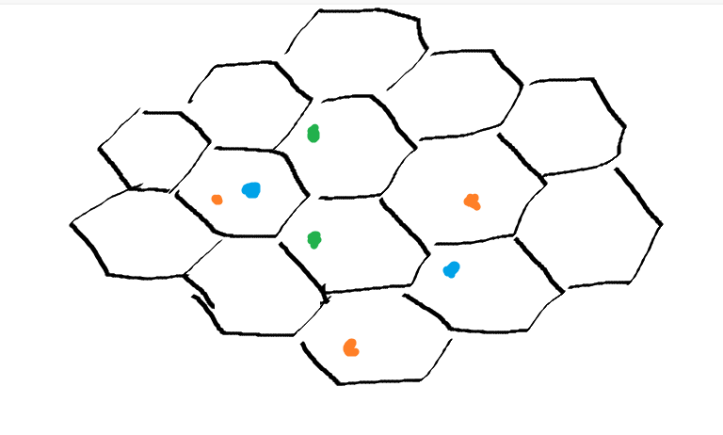

Figure Tessellation Grid with Points

Figure Example Choropleth Map from Minnesota Department of Health

**Results Verification**

Perform a sensitivity analysis

**Discussion and Conclusion**

*What did you learn? How does it relate to the main problem?*

**References**

*Use a common format*

**Self-score**

*Fill out this rubric for yourself and include it in your lab report. The same rubric will be used to generate a grade in proportion to the points assigned in the syllabus to the assignment.*

|  |  |  |  |
| --- | --- | --- | --- |
| **Category** | **Description** | **Points Possible** | **Score** |
| **Structural Elements** | All elements of a lab report are included **(2 points each)**:  Title, Notice: Dr. Bryan Runck, Author, Project Repository, Date, Abstract, Problem Statement, Input Data w/ tables, Methods w/ Data, Flow Diagrams, Results, Results Verification, Discussion and Conclusion, References in common format, Self-score | 28 |  |
| **Clarity of Content** | Each element above is executed at a professional level so that someone can understand the goal, data, methods, results, and their validity and implications in a 5 minute reading at a cursory-level, and in a 30 minute meeting at a deep level **(12 points)**. There is a clear connection from data to results to discussion and conclusion **(12 points)**. | 24 |  |
| **Reproducibility** | Results are completely reproducible by someone with basic GIS training. There is no ambiguity in data flow or rationale for data operations. Every step is documented and justified. | 28 |  |
| **Verification** | Results are correct in that they have been verified in comparison to some standard. The standard is clearly stated **(10 points)**, the method of comparison is clearly stated **(5 points)**, and the result of verification is clearly stated **(5 points)**. | 20 |  |
|  |  | 100 |  |